|  |
| --- |
|  |
| VIRTUAL DOCTOR |
| MINI PROJECT REPORT |

|  |
| --- |
| Programmed and Presented by:  TEJASH SHRESTHA  SUPREETHA ACHAR K  YASHEKA V  RAHUL PAI |
|  |



**NITTE MEENAKSHI INSTITUTE OF TECHNOLOGY**



**(AN AUTONOMOUS INSTITUTION)**

**AFFILIATED TO VISVESVARAYA TECHNOLOGICAL UNIVERSITY, BELGAUM**

**(APPROVED BY AICTE & GOVT OF KARNATAKA)**

Department of Computer Science and Engineering

Mini Project Report on

**“VIRTUAL DOCTOR”**

Submitted by

TEJASH SHRESTHA SUPREETHA ACHAR K

1NT14CS206 1NT14CS164

YASHEKA V RAHUL PAI

1NT14CS187 1NT14CS119

Under the Guidance of

Dr.MN Thippeswamy

HOD &Professor

Department of Computer Science and Engineering

**NITTE MEENAKSHI INSTITUTE OF TECHNOLOGY**



**(AN AUTONOMOUS INSTITUTION)**



**AFFILIATED TO VISVESVARAYA TECHNOLOGICAL UNIVERSITY,BELGAUM**

**(APPROVED BY AICTE & GOVT OF KARNATAKA)**

Department of Computer Science and Engineering

CERTIFICATE

Certified that this project report “VIRTUAL DOCTOR" is the bonafide work of "Tejash Shrestha, Supreetha Achar K, Yasheka V, Rahul Pai”. The project work was carried out under my supervision.

Signature of the Guide & HoD:

Name: Dr. MN Thippeswamy

HOD & Professor

EXAMINER:

1:

2:

ACKNOWLEDGEMENT

The credit for the successful completion of this project work goes beyond our own work, to those people who have always been with us throughout. And we take this opportunity to express our heartfelt gratitude to each one of them.

We express our sincere thanks to our Mentor and HOD, **Dr.M N THIPPESWAMY,** Department of computer science and engineering for his valuable suggestions and providing guidance throughout the project, that enabled us to complete this project successfully.

We extend our thanks to faculty of Department of CSE for their effort and endurance to bring out the best in all of us.

ABSTRACT

The main aim of our project is to provide an instant and portable method of treating patients and also to facilitate people with the necessary first-aid or medicines for immediate requirements.

This project is intended to generate a meaningful set of details about the diseases, evaluation of symptoms and the medicines for the particular diseases. This project is a doorstep doctor and will provide effective solution to the symptoms or the disease provided. This also provides the address of the nearest hospital available.

Table of Contents

1. INTRODUCTION 6

2. SYSTEM ANALYSIS 7

2.1 EXISTING SYSTEM 7

2.2 PROPOSED SYSTEM 7

2.2.1 SCOPE OF THE PROJECT 7

3. AIM OF THE PROJECT 8

4. PROJECT MODULES 8

5. REQUIREMENT SPECIFICATIONS 9

5.1 DETAILS OF SOFTWARE 9

5.2 SYSTEM REQUIREMENTS 9

5.2.1 HARDWARE CONFIGURATION 9

5.2.2 SOFTWARE CONFIGURATION 9

6. SYSTEM DESIGN 10

6.1 FLOW CHARTS 10

7. SYSTEM IMPLEMENTATION 11

7.1 MODULAR DESCRIPTION 11

8. RESULT 13

9. CONCLUSION 21

10. REFERENCES 21

# INTRODUCTION

The" VIRTUAL DOCTOR" is a substitute to the local primary healthcare system. It acts as a charity at the intersection of technology and medicine. As it is hard for people who stay in remote areas to travel long distances and heavy travel expenditure, this application provides a faster way to detect health problems. It provides better healthcare at your fingertips. This acts as a medical consultant at your doorstep. The software developed at the end of this project detects the disease affected to the user based on the symptoms given as the input by the patient. The symptoms that are 60% matching with the diseases are displayed. The software also prescribes some of the medicines and gives precautions to treat the disease. The code is a prototype of actual virtual doctor software, which can be built by including more number of diseases.

It is hard to get to know about the diseases one has by manual judgment, so we have included both methods of search i.e. one can give disease as a input and get to know its symptoms and medicines or can input the symptoms and get to know the disease and is available any time needed. This application is an economy one as it save people’s money and time too. Lot of expenditure is cut off, like doctor’s consultation fee, travelling expenses etc.

# SYSTEM ANALYSIS

## 2.1 EXISTING SYSTEM

Currently there are only limited facilities available such as meeting the doctor personally where the time consumed will be more and in the present days e-consultation is also available to help the patients.

## 2.2 PROPOSED SYSTEM

### 2.2.1 SCOPE OF THE PROJECT

The main function of this software system is as follows:

* The software provides the patients to detect there diseases by themselves.
* It also allows them to find a solution to their health problems without the consult of the doctor.
* It eliminates the disadvantage of delayed care on the health problem.
* Provides consultancy service round the clock.
* Eliminates appointment system and saves a lot of time.
* The software can be updated to include new medicines.

# AIM OF THE PROJECT

[1]This project is aimed to provide a tool for easy consultation at the finger tips in an efficient and an easy manner. The purpose of the project entitled as “VIRTUAL DOCTOR” is to computerize all the activities by developing the required software which will help people to analyze the diseases, their symptoms and provide required medical description provided the application is regularly updated whenever available.

The main aim of the project in hand is to provide an improved, faster and instant approach of diagnosing and prescribing medicines to different diseases. The patient himself able to know the causes of his disease and will get the basic precautions to be taken to get rid of the disease and some of the medicines that can be prescribed for the disease detected.

# PROJECT MODULES

The project has been slashed into many small modules to run effectively, easy to understand and debug. Some important modules used in the project are:

* Home module
* Disease Search module
* Symptoms search module
* Medicines search module
* Tabs module
* Exit module

# REQUIREMENT SPECIFICATIONS

For software to run fluently, hardware configuration should be matched with the software configuration, as the coordination results the best.

## 5.1 DETAILS OF SOFTWARE

The program is been designed by making use of turbo c along with the use of graphics library. The system we have used to develop this software has the following configuration:

* Core i5 processor.
* 8 GB RAM.
* 1TB hard disk.
* 2 GB graphics.

## 5.2 SYSTEM REQUIREMENTS

### 5.2.1 HARDWARE CONFIGURATION

This software will run on a system containing at least following configuration:

* 1 GB RAM.
* 50 GB hard disk.
* 1 GB graphics.
* Pentium processor.

### 5.2.2 SOFTWARE CONFIGURATION

The software is been designed using turbo c in windows operating system. It has to be used on the specific system.

# 6. SYSTEM DESIGN

## 6.1 FLOW CHARTS

Info About the program

Home

Disease Search

Evaluation Of Symptoms

Medicine Search

Exit

Loading

# 7. SYSTEM IMPLEMENTATION

The program is been designed by making use of different modules and these modules help each other in the effective working of the program to give a specified result.

## 7.1 MODULAR DESCRIPTION

* **INFO MODULE:**

This is the first page of our program which gives information about the need for the “VIRTUAL DOCTOR” and gives brief information about the importance of this technology and how can this technology be used to know about your diseases without consulting a doctor.

* **HOME MODULE:**

This module gives the information about the different tabs that are being used in the program. The user can make use of this home module to know about the tabs which he or she has to make use. In the program we have made use of tabs like disease search, evaluation of symptoms and medicine. In the disease search tab we can know about the known diseases or infection. Using the evaluation of symptom tab we can know about our disease through the help of symptoms. The medicine tab has some of the medicines that can be prescribed for the disease detected.

* **DISEASE SEARCH MODULE:**

This tab helps you to have glance about the known disease or

infection. By typing you can know its symptoms and precautions.

The user has to give the disease name that he is suffering from and he will be able to know about the major symptoms of that disease and will be even able to know about some of the major precautions that he has to follow to recover.

* **SYMPTOM SEARCH MODULE:**

If the user is having certain symptoms and if he is not aware of the disease that he is suffering from, the user can make use of this module and know about his disease. What the user has to make is, he has to give his symptom and he will be able to know about the disease.

* **MEDICINE SEARCH MODULE:**

If the user is aware of his disease already he can get to know about some of the medicines that can be prescribed for the disease detected. Only some major medicines which can be prescribed are given in the disease module which the user can make use of.

* **EXIT:**

This module has the information about the programmers. It has the names of the programmers and this the way out of the program.

# 8. RESULT

In this section, the results obtained for the proposed project are briefly discussed. The Figure 8.1 shows the information about the project. The user is expected to click on next button to continue with our system. The figure 8.2 shows the display when user clicks on next button. The figure 8.3 shows the main page of the program. The figure 8.4 displays the disease search box when clicked to disease search tab. Figure 8.5 gives the symptoms of common cold and figure 8.6 the precautions of common cold. The figure 8.7 displays the page of evaluation of symptoms when clicked on that tab. The figure 8.8 shows all the symptoms starting from the entered letter is displayed on the screen. After the disease is detected figure 8.9, 8.10, 8.11 shows the symptoms, precaution and medicines for the detected disease. Figure 8.12 displays the medicines tab where user can enter the disease name to know the medicines prescribed for it. Figure 8.13 displays the medicines prescribed for entered disease. Lastly, figure 8.14 shows the exit tab which gives information about the programmers and a key to exit the program.

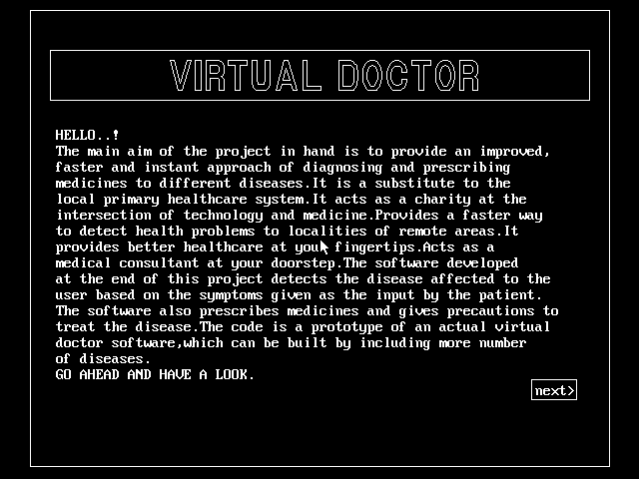

Figure 8.1: Information page of the proposed project.



Fig 8.2: The display after the user clicks on the next button.

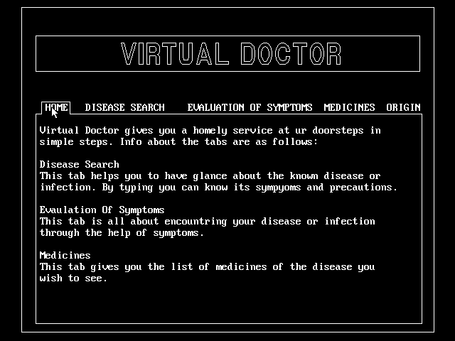

Fig 8.3: The main page of the project where the tabs are displayed.

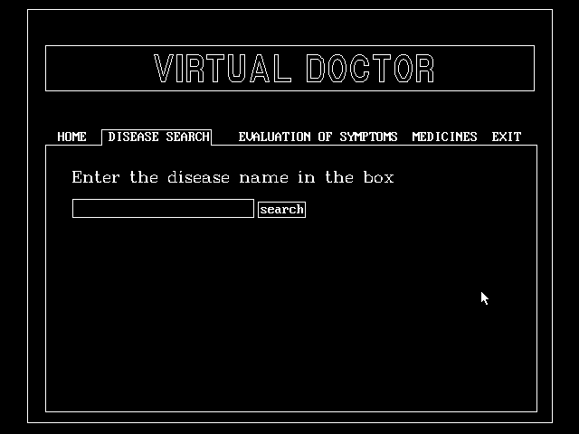

Fig 8.4: The disease tab- User can enter the name of the disease to get its details.

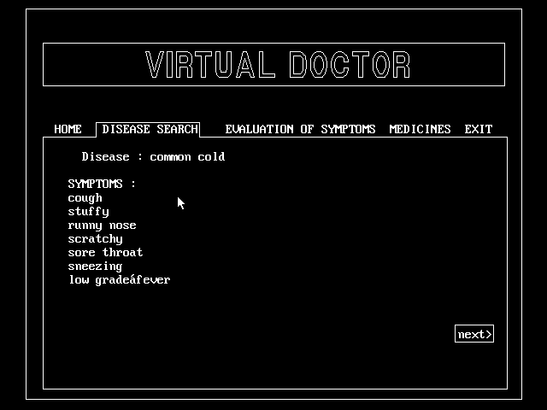

Fig 8.5: The details of common cold are displayed on the screen.

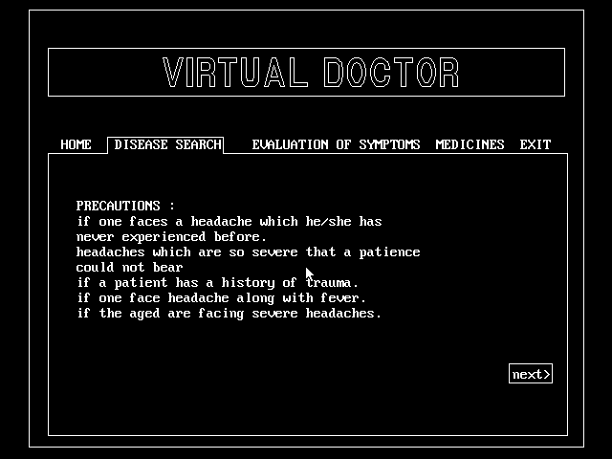

Fig 8.6: The precautions of the enter disease.

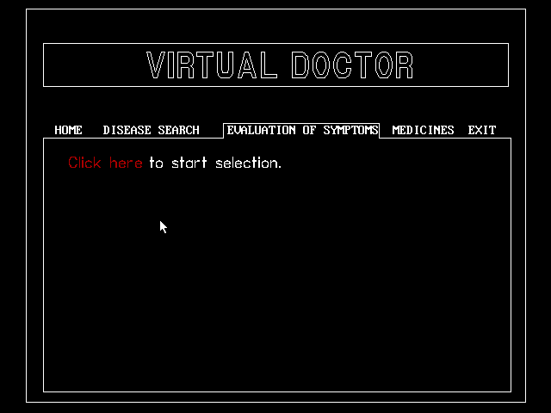

Fig 8.7: The evaluation of symptoms tab-user enters the symptoms to know there disease.

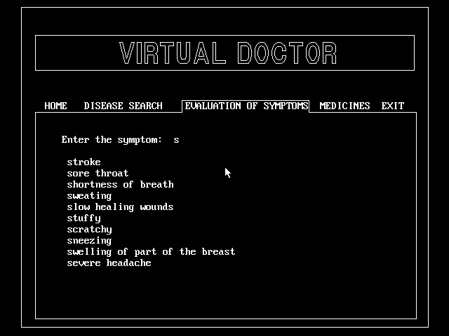

Fig 8.8: All the symptoms starting from the enter letter is displayed on the screen.

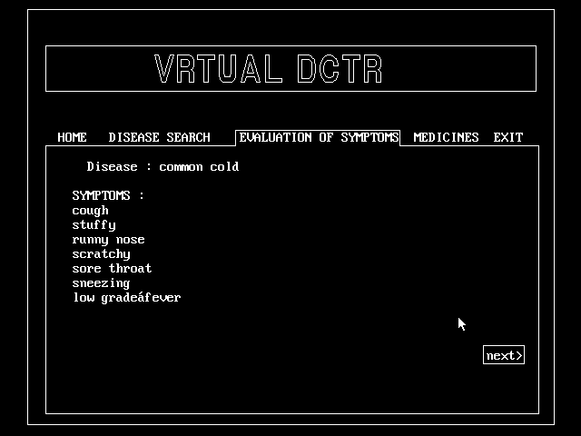

Fig 8.9: The detected disease with its symptoms.

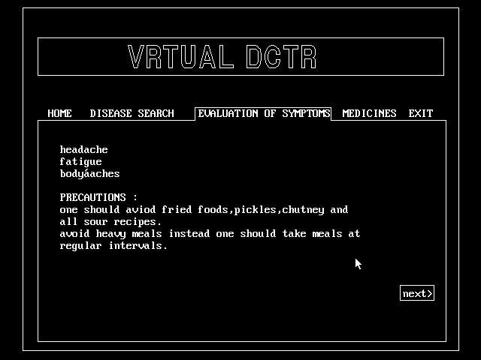

Fig 8.10: The precautions of the detected disease.

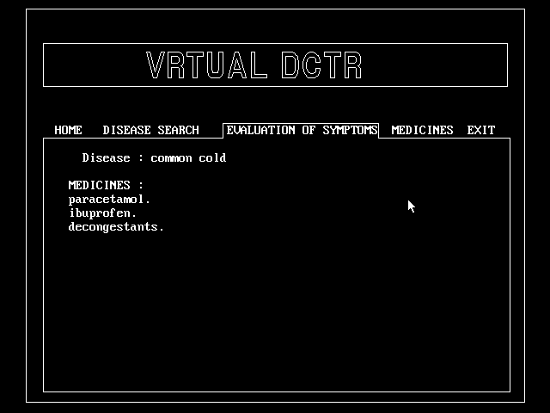

Fig 8.11: The medicines prescribed for the detected disease.

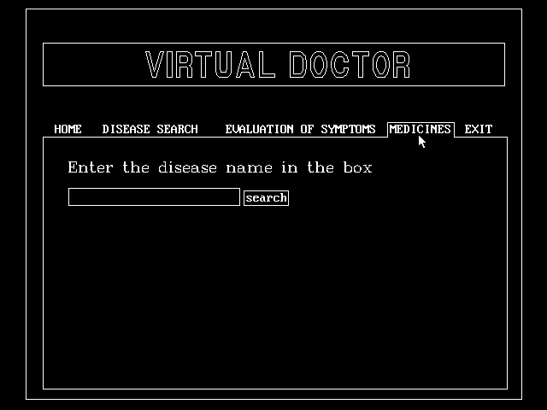

Fig 8.12: The medicines Tab –User can enter the disease name to know the medicines prescribed for it. 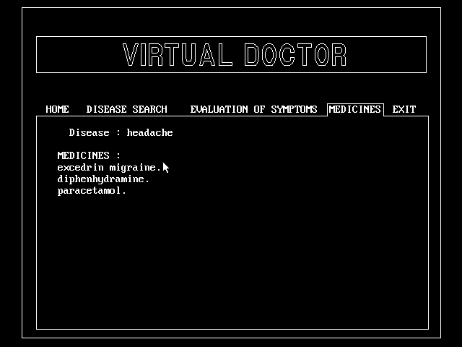

Fig 8.13: The medicines for headache displayed on the screen.

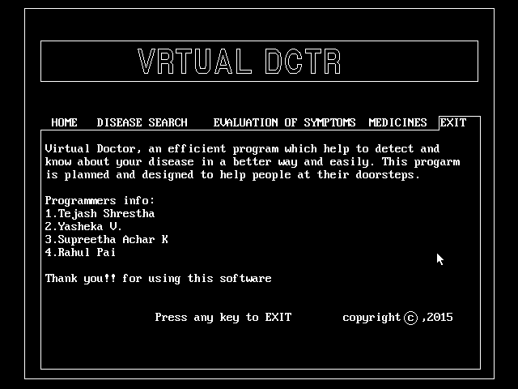

Fig 8.14: The Exit Tab which displays the programmers of the project.

# 9. CONCLUSION

Now the patients who need instant care can use this software to get the necessary precautions to be taken so that the patient stays safe before serious action are taken. The patients need not run to the doctor for suggestions in case of minor health problems like common cold, headache etc.. Therefore, all the following features of the project make it efficient to act as an effective healthcare center.

This project helped us a lot in enhancing our knowledge in programming. It also helped us have a good start with graphic programming. It provided a base to execute our ideas.

# 10. REFERENCES

The information in the report provided was derived from the following sources:

* [www.google.com](http://www.google.com)
* <http://www.virtualdoctors.org/#home>

[1] THE VIRTUAL DOCTORS